caEHR

Test Automation Plan

Document Change History
Version Number | Date | Contributor | Description
V0.1 | 6/24/2010 | Jim Jones | First Draft
V0.2 | 6/30/2010 | Jim Jones | Added tooling spreadsheet and narrative.
V0.3 | 7/21/2010 | Jim Jones | Changes throughout to reflect decision to use soapUI instead of Service Test. Also minor edits
V0.4 | 7/23/2010 | Jim Jones | Updated Functional Test section to clarify role of each tool relative to serialization/desrialization.
V0.5 | 8/21/2010 | Jim Jones | Added Arch Diagram for JUnit Framework and supporting text.


Updated September 10, 2010
Table of Contents

1 Introduction 2
1.1 Project Overview 2
1.2 System Overview 2
1.3 Document Overview 2
1.4 Relationship to Other Documents/Plans 2
1.5 Assumptions 2
1.6 Constraints 2
2 Automation Tool Categories 3
2.1 Test Management 3
2.2 Functional Testing 3
2.3 Performance Testing 3
2.4 Integration for Traceability 4
2.5 Continuous Integration 4
3 Proposed Implementation 4
4 Test Management Tool Evaluation 6
5 Functional Test Tool Evaluation 6
5.1 Web Services Operations Testing 7
5.2 Serialization/De-serialization Testing 7
6 Performance Testing 8
6.1 Scenario Design and Scripting 8
6.2 Cloud Infrastructure 9
6.3 Test Environment Provisioning 9
6.4 Monitoring 9
7 Integration for Traceability 9
7.1 Traceability to Requirements 9
7.2 Traceability to Defects 10
8 Continuous Integration 10
8.1 Execution of soapUI Tests 10
8.2 JUnit Tests 11

Introduction
This test automation plan describes the selection and planned implementation of tooling to support the Quality Assurance and Testing activities of the Center for Biomedical Information and Information Technology (CBIIT) Ambulatory Oncology Electronic Health Record (caEHR) project.

Project Overview
The goal of the caEHR project is to support the Ambulatory Oncology sector, in the delivery of improved patient care through the development of consensus based health IT standards and solutions that meets this sector unique EHR needs.

System Overview
The caEHR project will develop service specifications that will be adopted in the Ambulatory Oncology sector to meet the unique EHR needs of that sector to provide improved patient care.

Document Overview
This Test Automation Plan explain the evaluation process, status and proposed implementation for the toolset proposed to support all QA testing activities.

Relationship to Other Documents/Plans

This plan references the following Plans:
Performance Test Plan

Assumptions
At the onset of the project there was not enough time to do a protracted tool selection. The HP Test Suite was included in the proposal so it was assumed that this suite would meet our needs. The QA Team proceeded to evaluate the toolset with special focus on its operation in a cloud environment and its integration with tools selected by other teams.

Constraints
JIRA Studio was immediately selected and implemented by the ESD Team. Integration of the QA toolset with JIRA Studio was therefore a constraint.
JAMA Contour was selected by the Analysis Team as their Requirements Management tool. Integration of the QA toolset with Contour was therefore a constraint.

Automation Tool Categories

Test Management
A test management tool is the central tool for the QA Team to perform all of its basic tasks:
Design test cases
Execute test cases
Report/track defects
Assure requirements traceability/coverage
Report test metrics

HP Quality was evaluated and selected as the QA Team test management tool.

Functional Testing
In its functional test automation approach the QA Team considered that coverage was required not only for the web service operations but also for the serialization/de-serialization into and out of XML. This last part was imperative because the caEHR web services are initially being developed without a reference implementation in which to test them.
For this reason, QA has decided upon a “headless” client tool for web services testing at the XML request/response level and Java-based approach using a web services client for testing serialization/de-serialization.

QA considered the following “headless” clients for test of web service operations at the XML request/response level:
Service Test
SoapUI

SoapUI was selected by the QA Team because Service Test 9.5 has compatability issues with wsdl 2.0-based wsdls.

QA is augmenting its functional automation with a Java-based programmatic approach based on the JUnit test framework. This will incorporate a Java web services client which will test serialization/de-serialization.

Performance Testing
A performance test tool is required to execute web service operations in sufficient numbers and in a controlled fashion to measure the web service’s responsiveness. LoadRunner and Neoload were evaluated for the purpose. Both LoadRunner and NeoLoad had compatability issues with wsdl 2.0-based wsdls. LoadRunner has a more robust scripting capability and provided the ability to import a working request (generated in soapUI) into the Loadrunner script. LoadRunner also integrates with Quality Center. For these reasons, LoadRunner was selected as the perfromance testing tool.

Integration for Traceability
Due the constraints noted in the Constraints section, it was necessary to evaluate and assure that QA had a reliable way to integrate with the ESD and Analysis toolsets. JIRA Bridge was evaluated and selected for integration of defects between Quality Center and JIRA Studio. Contour/QC Integration was evaluated and selected for integrating requirements between Quality Center and Contour.

Continuous Integration
The QA Team wants to integrate its functional test suites into the builds and deploy process. The evaluation process included:
- Execution of a QC Test Suite from the command line using QC API to integrate the Service Test automation with the build and deploy process.
- Executing soapUI tests from ANT
- Executing a JUnit suite from ANT.

Proposed Implementation
The following diagram shows the proposed integrated implementation of all the QA tools.

The remainder of this document will discuss the tools within this implementation context.

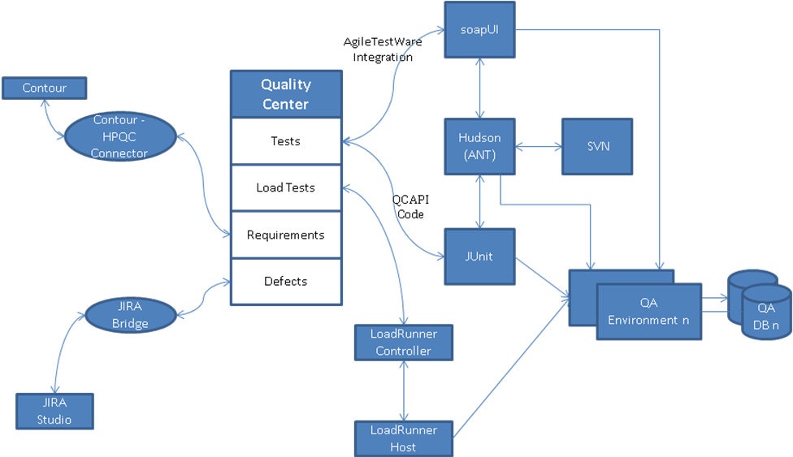

The QA Team has identified different levels of testing that need to be performed at different points in the agile development cycle. The following spreadsheet shows how each of the proposed tools will be used for those various levels of testing.

TOOL | LOCATION/ACTIVITY
TOOL | CI | "QA Tag" | "QA Trunk" | Performance | UAT1 | UAT2 | UAT3 | UAT4 | UAT5 | DEMO
TOOL | Every Check in | Deployed for Each Sprint | Deployed Daily (3am) to QA on Successful Build (TAG) | Deployed periodically | Deployed Infrequently | Deployed Infrequently | Deployed Infrequently | Deployed Infrequently | Deployed Infrequently | Deployed Infrequently
Java (custom coded) Tooling | Smoke | Smoke | Smoke | Smoke | Smoke | Smoke | Smoke | Smoke | Smoke | Smoke
Java (custom coded) Tooling |  |  | Programmatic Test Generation
Java (custom coded) Tooling |  |  | Serialization/De-serialization
Java (custom coded) Tooling |  |  | Web Client
soapUI |  |  | Fix Validation
soapUI |  | Regression | Regression |  |  |  |  |  |  | Regression
soapUI |  |  |  |  | Deployment Scenarios | Deployment Scenarios | Deployment Scenarios | Deployment Scenarios | Deployment Scenarios
soapUI |  | System Testing
soapUI |  | Requirements Testing
soapUI |  | Architecture/ ECCF Testing
soapUI |  | Design Testing
soapUI |  | 21 CFR
soapUI |  | HIPAA Compliance
NIH Security Scans |  | Security
NIH 508 compliance test tool |  | 508 Compliance
HP LoadRunner |  |  |  | Performance
soapUI/XML Spy | Test Analysis/Test case Construction
HP Quality Center | Test, Defect, Requirements Mgmt

Issues and Risks
soapUI Pro Installation on Demo and at External UAT Test Sites
soapUI needs to be integrated with QC.
Testing in Trunk requires dedicated resources for daily changes and Scripts maintenance
NIH Security Scanning tool compatibility with web services/test environments
NIH 508 compliance test tool compatibility with web services/test environments
Requirements testing with soapUI - full implementation with Contour Bridge product
Need CDO 224 - successful build tag implementation.

Test Management Tool Evaluation
A test management tool provides the QA Team with a central repository for designing test cases, executing tests, reporting/tracking defects, and publishing test metrics. The primary candidate tool for Test Management for caEHR is HP Quality Center (QC). QC is the premier test management tool in the marketplace. Due to its well-established position in the market, it provides two distinct advantages:
- QA resources with QC experience are readily available.
- Third party integrations with other SDLC tools are available.
A key objective for the caEHR project was traceability. QC provides traceability from the requirements to the test cases to the defects.

QC was evaluated to assure that it will meet the needs of the QA Team. The following actions were performed as part of the evaluation:
- QC was installed on an Amazon cloud instance
- Users and Project administrators were defined
- Sample requirements were defined in the Requirements Module.
- Releases were defined in the Releases Module and Requirements assigned to a Release.
- Sample test cases were written
- Sample tests were automated with HP Service Test
- Versioning

Functional Test Tool Evaluation
Functional Testing of web services is complex. It is quite different from GUI-based testing. Typically, the main focus of web services testing is to exercise all of the operations contained within each web service. Usually this is done from within a web application which uses the web service operation. When used within a web application, the serialization/de-serialization of objects to xml and xml to objects happens as part of the testing. This is shown in the following figure.

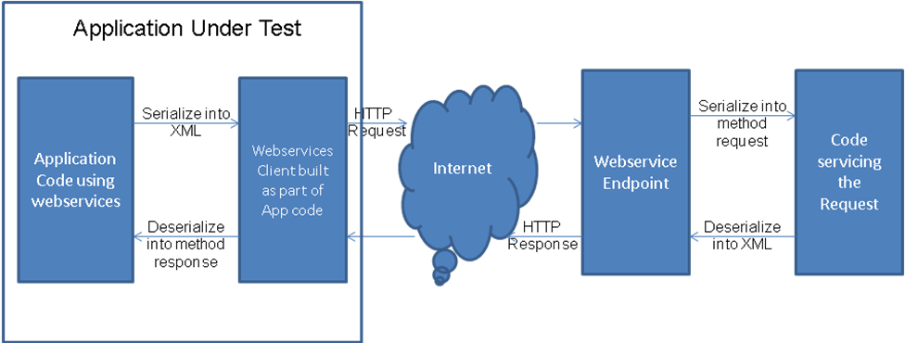

Since caEHR has no reference implementation, the web services are being tested independent of any application. Therefore, our functional testing approach needs to cover both web service operation testing as a well as serialization/de-serialization.

Web Services Operations Testing
HP Service Test and SoapUI from Eviware are commercially available tools for functional testing of Web services. Both of these fall into a category of tools referred to as “headless clients.” They operate at the XML request and response level and do not test serialization/de-serialization of the XML into/out of code objects. The following figure shows how these tools fit into the web services testing infrastructure.

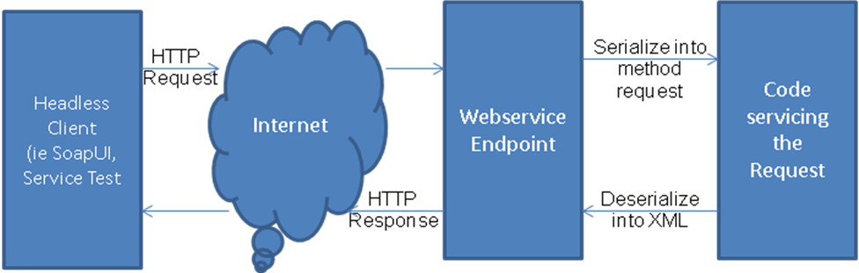

Each of these tools offered advantages and disadvantages making neither one a clear choice. For instance, while Service Test offers tight integartion with Quality Center, the Service Test 9.5 version does not support WSDL 2.0 and was unable to import the first WSDL that was delivered by Architecture. HP provided a Services Test 11.0 beta version but that version was unable to access and set the attributes and values for the HL7 datatypes.

SoapUI, on the other hand, has been used fairly heavily by the QA team pending the purchase of the selected toolset. SoapUI is able to import our WSDLs that are based on WSDL 2.0 but the tool sometimes is very slow because of the size of the resulting imported request. soapUI does not integrate with Quality Center and solution needs to be developed or found for this.

After evaluation of these two tools, the leading choice is soapUI because it offered a solution to the technical issues.

Issue – soapUI to Quality Center integration product from Agiletestware has recently been identified and will be evaluated in an upcoming sprint. I may also be preferred to keep the soapUI artifacts in SVN (rather than Quality Center) for CI purposes and write a custom integration for getting the soapUI test results into Quality Center.

Serialization/De-serialization Testing
As mentioned above, caEHR web services are being tested independent of any application. To test serialization/de-serialization of the XML, the QA team is also investigating additional testing approaches based on a Java Web services Client and JUnit test cases. The following figure shows how this tool fits into the web services testing infrastructure.
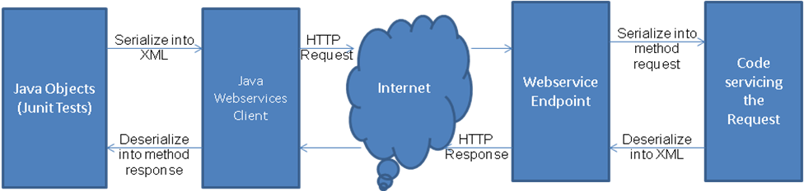

Java-based Service Test Tool Architecture
The following diagram shows the architecture of the Java-based automated testing approach.
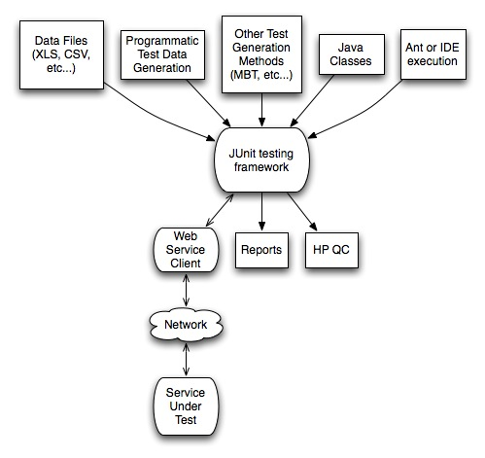

The key components shown at the top of the diagram are the Data Files and Java Classes. The JUnit Test Framework uses a data-driven approach of reading a data file which defines the classes that need to be built for the service request being tested. The Java Classes are generated from the wsdl files provided by the Architecture team. These combine to form a Java-based web service which is executed via a web services client. This represents an end-to-end test which includes the serialization/deserialization of the webservice from Java objects to XML and back again when the response is received.

The architecture diagram further shows that the framework has extended capabilities of programmatically generating test data, integrating with the Continuous Integartion process, integrating with Quality Center, and supporting other test generation methods.

Performance Testing
The basic strategy during the first round of Component level performance tests is to identify the relative performance of each Service under a common set of load assumptions. Two categories of tests will be performed, benchmark and degradation tests. In this way we will be able to identify which services perform relatively well and those which perform poorly for a given set of load assumptions.

Subsequent rounds of Performance Testing will include Use Case testing for logically related Sets of Service/Operation calls and also Reference Implementation tests for the initial Deployment sites for caEHR services.

Scenario Design and Scripting
There are two categories of Performance Requirements we generally look for, Workload Expectations and then Response Time Expectations for that workload. The Workload Expectations usually reflect the expected transaction volume for the Services and the Response Time Expectations reflect the requirements for response times while the system is loaded with the expected transaction volumes. Since we don’t have those expectations yet, we will use a Benchmarking approach and a scaled Degradation approach. The Performance Test Plan will outline a Workload Characterization Matrix for each web service.

LoadRunner test scripts will be developed for each Release/Iteration/Sprint. Any functional test scripts developed in soapUI will be leveraged to whatever extent possible with additional data variation to prevent server caching.
LoadRunner does not have the capability to import a wsdl2.0-based wsdl. LoadRunner scripting will involve importing into soapUI, creating the desired test request, and saving the test request as an xml file. The saved xml file can then be imprted into a LoadRunner script.

Cloud Infrastructure
An evaluation license of the LoadRunner Controller was installed on a Windows instance in the Amazon cloud. The virtual users were hosted on the same instance for evaluation purposes. For QA testing separate cloud instance will be required for the Controller and Virtual User Host machines.

Test Environment Provisioning
To get meaningful and realistic performance test results a test environment must be provisioned that is representative of deployment site infrastructures. The Performance Test Plan will outline the performance test environment requirements in terms of server hardware, OS, software configuration and database size.

Monitoring
LoadRunner provides a great many statistics related to transaction response time and server activity. Usually additional infrastructure monitoring is helpful and necessary to enable Development to effectively tune and debug performance issues. The Performance Test Plan will outline the performance monitoring that will be performed as part of the performance test execution.

When performance testing commences, the QA Team will work with the CDO Team to determine the monitoring options available within the Amazon cloud and with the Development Team to assure that informative monitoring is being performed.

Integration for Traceability

Traceability to Requirements
Quality Center provides a requirements module where the Analysis Team can design and develop requirements. The Analysis Team evaluated this tool along with other Requirements Management tools and selected Contour from JAMA as their tool of choice. QA therefore evaluated a JAMA-provided Contour – QC integration tool. The following steps were performed to evaluate the integration.
- The integration software was installed on a cloud instance.
- Integration software was connected to a Contour demo project and a Quality Center demo project both on cloud instances.
- Mappings were done from Contour fields to Quality Center fields.
- Verified that field updates in Contour were propagated to Quality Center for new and existing requirements
- Verified that requirements could identified as belonging to a release

This integration allows the Analysis team to work in Contour and synchronize the requirements to Quality Center. Once the requirements are synchronized to Quality Center, the QA Team uses them to develop test cases. The traceability capability within Quality Center allows each test case to be mapped to requirement(s) and thereby show traceability and test case coverage.

Mappings for Release values are hard-coded in the mapping tool. Vendor committed to looking at more sophisticated ways of doing this based on the Releases defined in the Quality Center Releases Module.
Evaluation version of the integration did not support a Quality Center project with versioning turned on. Vendor committed to correcting this as part of deploying the software to us.

Traceability to Defects
The Development (ESD) team is using JIRA Studio as their primary work management tool. As such, ESD would like to have defects identified, worked and tracked within JIRA. The QA Team would like to use the Defect Module in Quality Center to maintain traceability in Quality Center between the requirement, test case and defect. The JIRA Bridge product from Orasi provides the capability to synchronize defects between Quality Center and JIRA. This allows a QA person to identify the defect in Quality Center to maintain this traceability. The developer has visibility of the same defect in JIRA. Changes can be made to the defect and be seen in either tool.
- The following activities were performed as part of the JIRA Bridge evaluation.
- The JIRA Bridge software was installed by Atlassian as an approved plug-in for JIRA Studio
- The JIRA Bridge was connected to the JIRA Dev project and a Quality Center demo project.
- A defect was created in Quality Center and propagated to JIRA.
- Verified that a target JIRA project could be identified on the Quality Center defect and that the defect was propagated to the correct project in JIRA.
- Verified that defect comments were passed back and forth between QC and JIRA.
- Verified that individual field updates (i.e. severity) were propagated properly in both directions in accordance with the defined field mappings
- Verified that propagation from JIRA to Quality Center could be restricted to just those defects that originated in Quality Center

- Defects have been entered directly into JIRA while the QA tool selection was progressing. CDO is investigating ways to do an initial “load” of defects from JIRA to Quality Center. This was not considered pass/fail criteria of the evaluation.

Continuous Integration
A goal of the QA Team is to integrate an automated test suite into the build and deploy process. As described in the Functional Testing section, functional testing will be accomplished with both Service Test and a JUnit implementation. This section will discuss the integration of each of these with the build and deploy process.

Execution of soapUI Tests
soapUI tests can be executed from the command line. Therefore the execution of a soapUI suite using an ANT script is possible which can be executed as part of the build process.
Integration of soapUI into the CI process has not been prototyped.

JUnit Tests
The choice of writing tests in Java and using JUnit as a test framework fits neatly into the CI environment as it easily executes and publishes results. Standard Ant build scripts may execute JUnit tests. Since Ant is supported by the Hudson CI server that means a test run may be triggered automatically by a successful deployment of ESD code. Publishing of JUnit results is also natively supported by the Hudson CI server so we may be able to see the cumulative results of tests executed over time. The test framework may be extended to allow reporting back to QC although this may require additional development.

- Implementation of the JUnit framework is still under development.
- JUnit results will need to be integrated with Quality Center via the Quality Center API.

